358. Taps And Dies
Thread cutting is more accurately and economically done by machine, but necessity frequently arises for cutting threads by hand. Taps and dies for hand work are made in many forms and sizes, of various standards of threads. They are usually made for cutting right-handed threads, as left-handed threads are used only for some particular requirement.
Fig. 209 shows a common type of machinists' hand taps for threading nuts. No. 1 is a taper tap, which may be used to ream out a hole and start the cutting of threads gradually, distributing the wear along the tap. No. 2 is a plug tap used for quicker cutting than the taper tap. No. 3 is a bottoming tap used after the plug tap for cutting threads to the bottom of a hole.
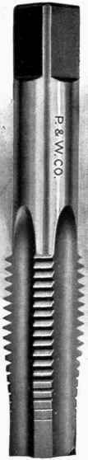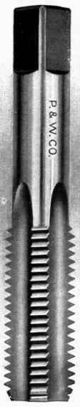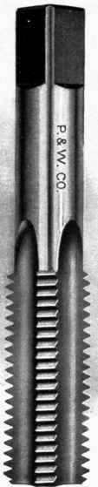
Fig. 209. - Taps.
A convenient form of die for bolt threading by hand is that shown in Fig. 210. This consists of a holder, made up of several parts, and four cutters. An extra set of cutters, or " chasers," is shown beside the die. These cutters may be adjusted to suit rods varying about 1/32-inch in diameter and may be readily removed for renewing.

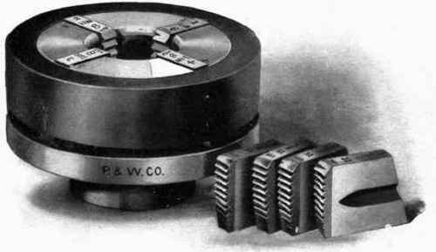
Fig. 210. - Threading Dies.
Fig. 211 shows a die-stock used for holding and turning the die, and an adjustable tap wrench B for turning the taps of Figs. 209.
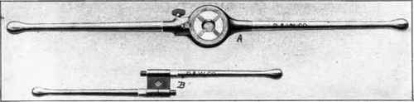
Fig. 211. - Die Stock and Tap Wrench.

About Taps
All taps and dies are marked with the diameter of bolt and nut they will cut, the number of threads per inch, and the class or standard to which the thread belongs.
SAE threads come in two styles, fine and coarse, this is determined by the number of threads per inch, for
example a fine thread 3/8" bolt would have 24 threads per inch, a course thread bolt would have 16
threads per inch.
Three common styles of taps, top tapered, center plug, bottom bottoming. | To prevent breaking taps use a tap guide to align the tap.
There are many different styles of taps used in the industry, however the average person tapping by hand
need only concern himself with four styles.
Taper:
Many threads are chamfered at the cutting end making this a very easy tap to start square.
Plug:
This has fewer chamfered threads and is the most common tap.
Bottoming:
This type of tap has very little chamfer and is used to cut threads almost to the bottom of a blind hole.
Pipe:
Used to cut pipe threads

Tapping Procedure:
Step 1:
Select proper size drill, drill hole, then countersink hole entrance to a diameter slightly larger than major diameter of the threads.
Step 2:
Mount peice to be tapped in a vise so that hole is in a vertical position. Cup your hand over the tap wrench and apply downward pressure as you turn the wrench. Turn two or three turns.
Step 3:
Remove wrench from tap, check if tap is square in the hole. Replace wrench, apply cutting fluid, using both hands turn tap one-quarter to one-half turn, then back three-quarters of a turn to break the chip. Continue one-half turn in, then back three-quarters.
About Dies
Split adjustable die and hexagon rethreading die.
There are fixed size and split adjustable dies which have a screw to expand the die for a better fit.
Hexagon rethreading dies are also available to clean up existing threads.
Using a Die:
Step 1:
Chamfer the end of the stock with a file or grinder, this should be as deep as the thread to be cut.
Step 2:
Mount the stock in a vise, make sure chamfered side of die is down, this is the side with the markings, hold the die stock with one hand cupped over center, apply downward pressure as you turn die until cut has started.
Step 3:
Apply cutting fluid, turn die stock with both hands, after each revolution reverse die one-half turn to break the chips.
Step 4:
After a few threads have been cut check the fit with a nut, adjust die if necessary.
Threads Per Inch And Tap Drill Size Chart
Size | Coarse | Drill | Fine | Drill
1/4" | 20 | 13/64" | 28 | 7/32"
5/16" | 18 | 17/64" | 24 | 9/32"
3/8" | 16 | 5/16" | 24 | 21/64"
7/16" | 14 | 3/8" | 20 | 25/64"
1/2" | 13 | 27/64" | 20 | 29/64"

